HOW TO REGISTER FOR A MOBILITY Application
For all CEEPUS applications: You have to register and create an account under My CEEPUS first.
Click on MY CEEPUS on the CEEPUS website www.ceepus.info

Click on “Click here to register”
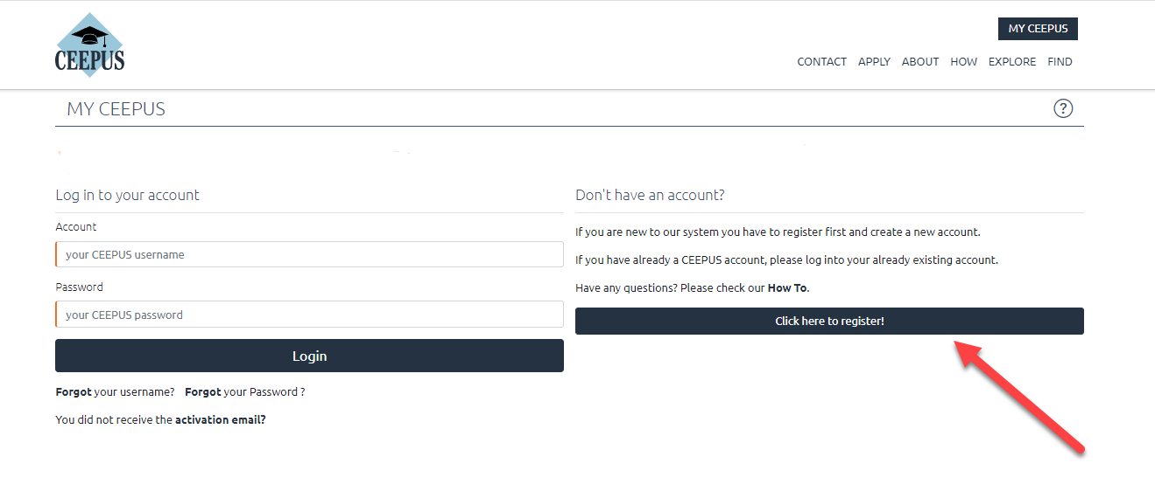In the next step please fill in the required data and click on submit
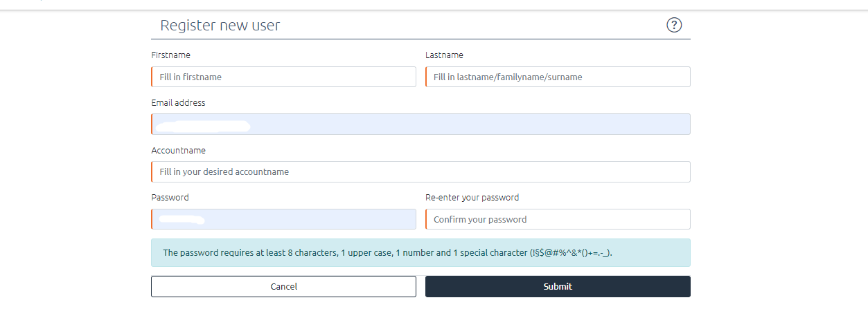

Now please check your emails, also check the spam folder. Then activate your CEEPUS account in your E-Mail.
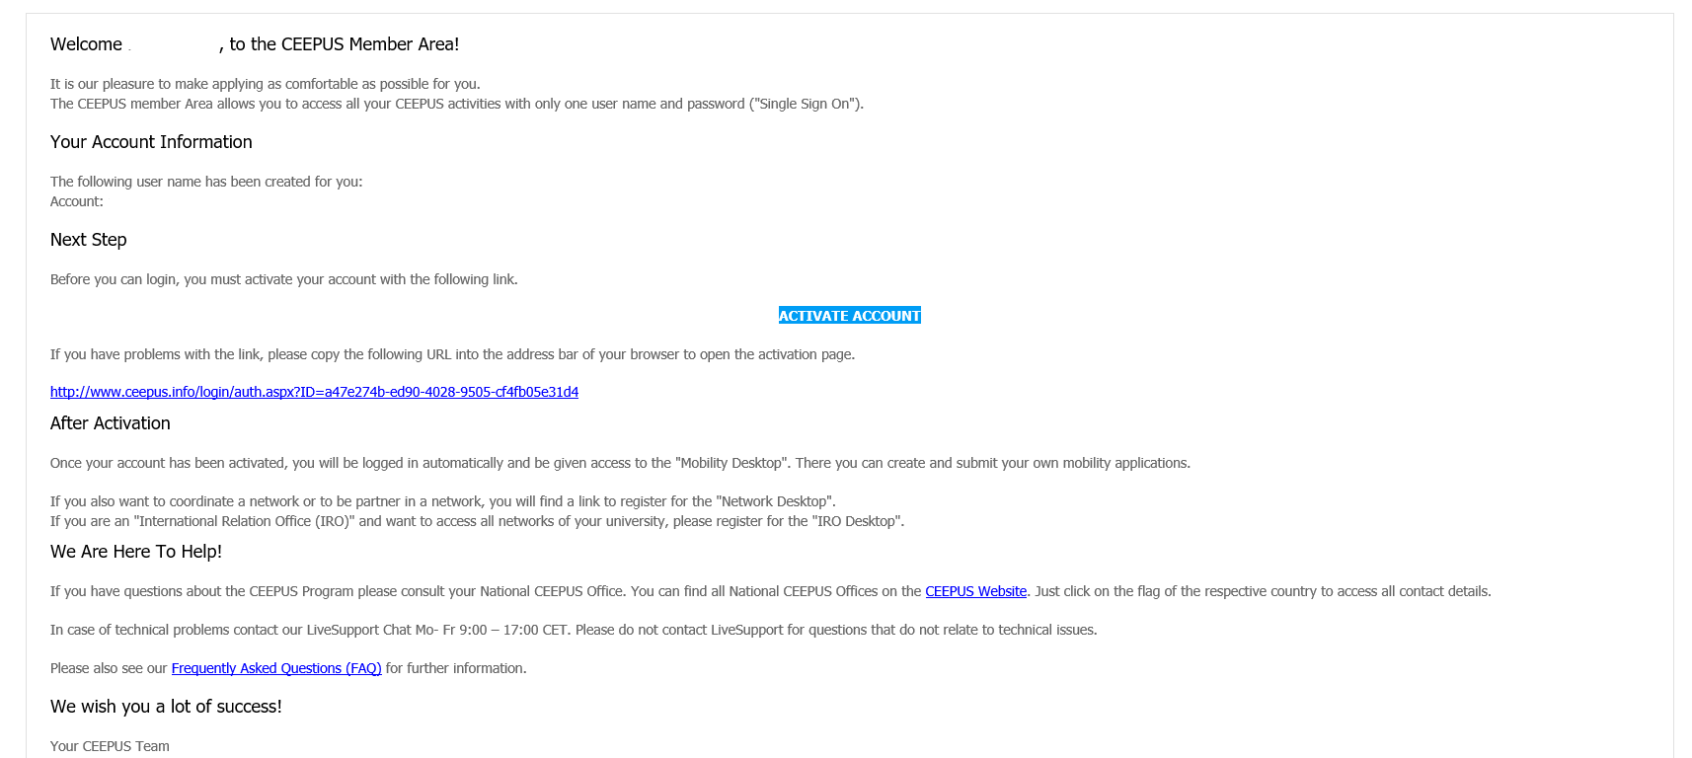

Now you have access to your CEEPUS Mobility Desktop, and you can apply/create new mobility applications.
