HOW TO apply for a CEEPUS Freemover grant – Ukrainian academics:
For all CEEPUS applications: You have to register and create an account under My CEEPUS first.

- After signing in: On your CEEPUS Mobility press „Create new application”:
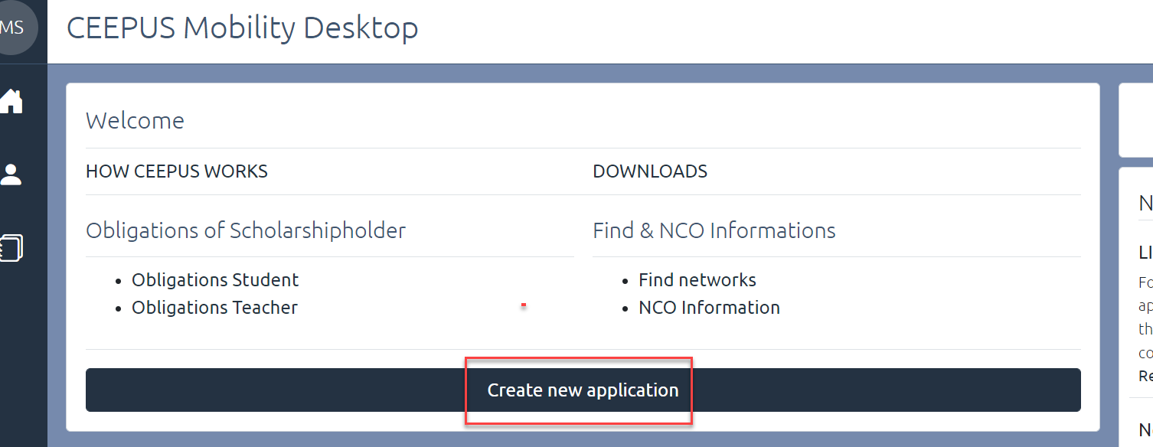

Activate “No” to apply as freemover, then press “next step”:
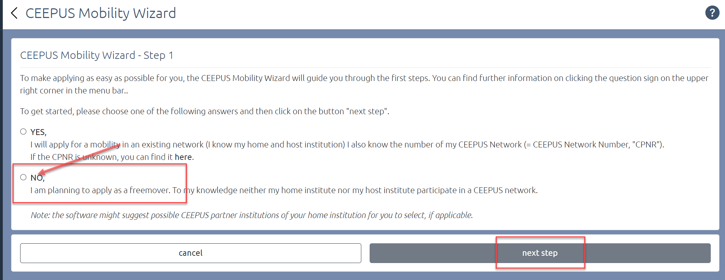

Please choose “Ukraine” as Home Country, “Ukrainian University (…)” in general as Home Institution, and “My home Unit is not on the list” under Home Unit.
Type in your Ukrainian university in the entry field.

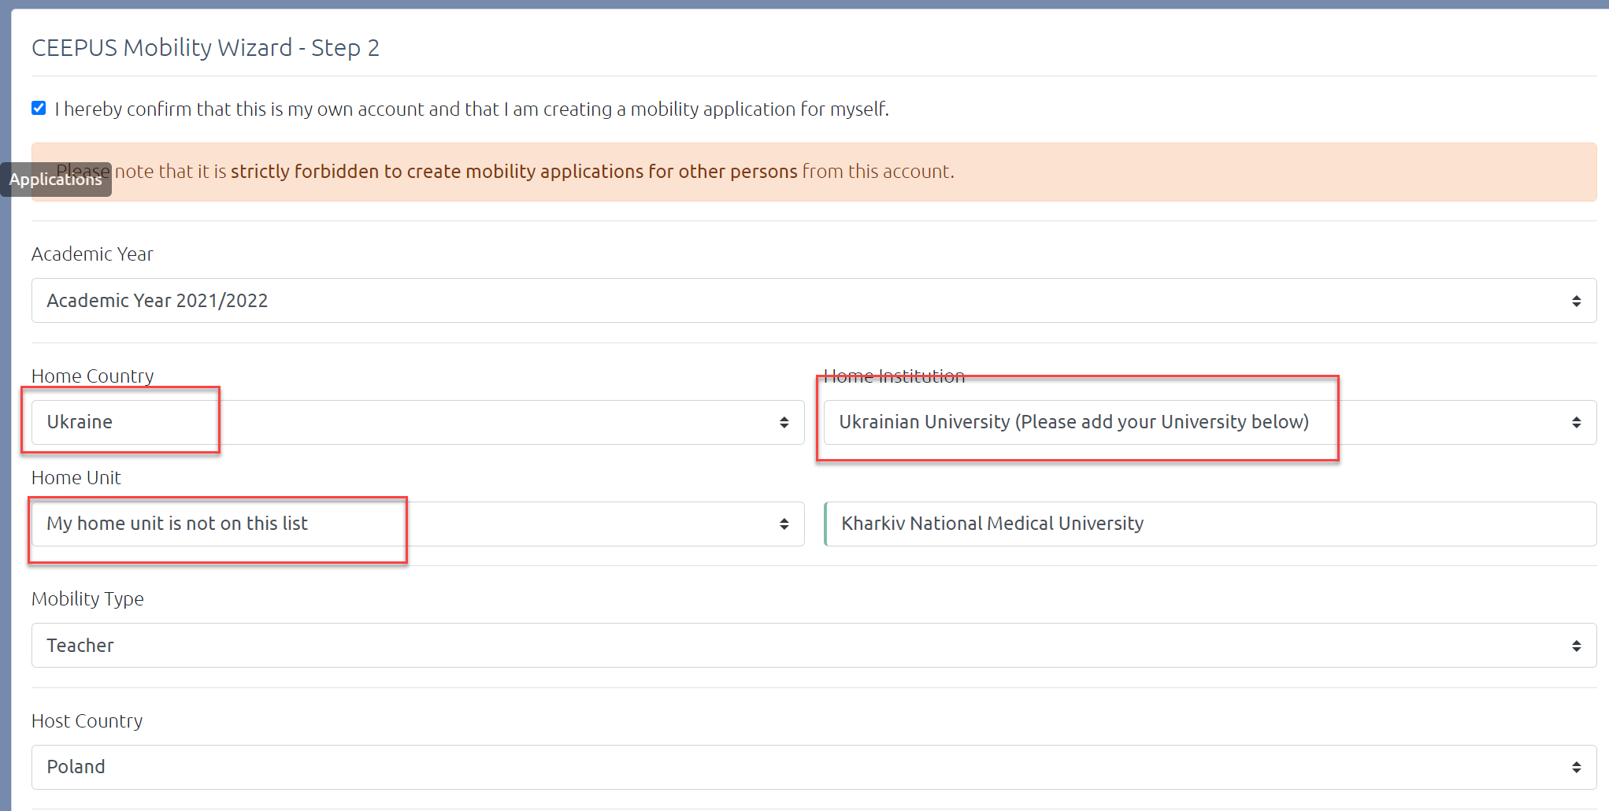

Please pick your host country and your host institution and then press “select >>”
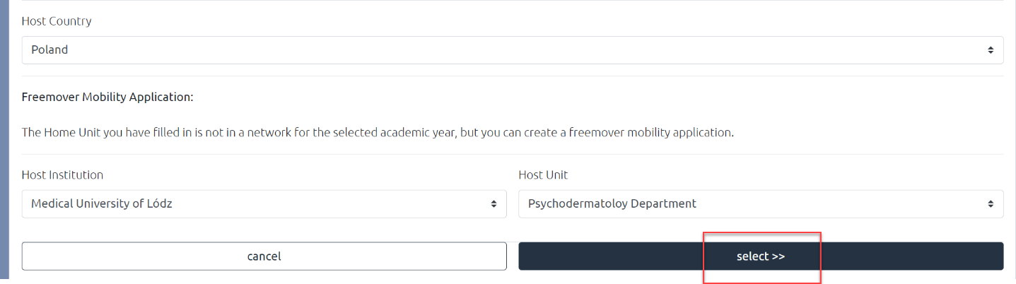

Now you see the overview of your application, with the different sections. Fill out all red marked sections.
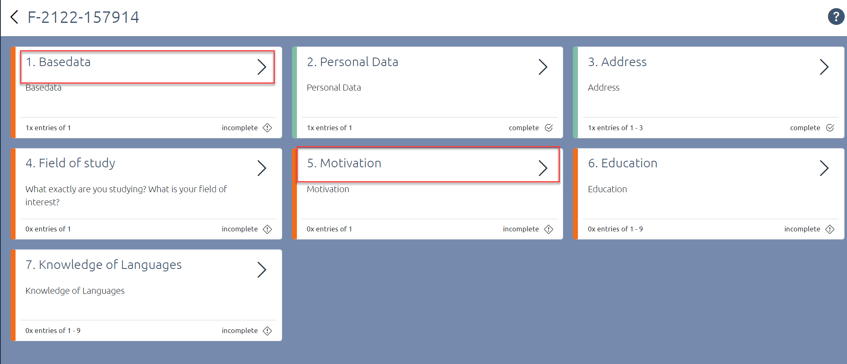

Under Basedata, you must fill in a duration of stay. Ask your contact person or our National CEEPUS Office for further advice.
You also need to upload a letter of acceptance or teacher letter from your host institution. Please access https://www.ceepus.info/content/downloads for a template.
Instead of a letter of recommendation, you should upload a confirmation of enrollment of your Ukrainian university or - as teacher - a confirmation of employment. Press “Edit Upload” to upload.
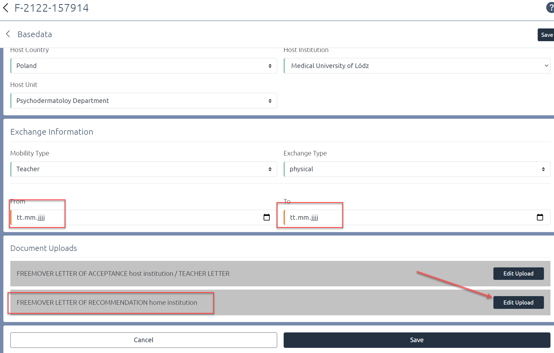
Do not forget to press “Save”.
Use the arrows to navigate.
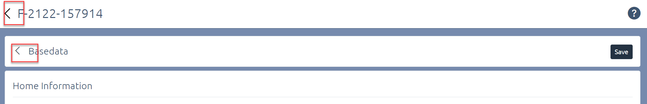

Once you have filled out all sections, navigate another step back to submit the application
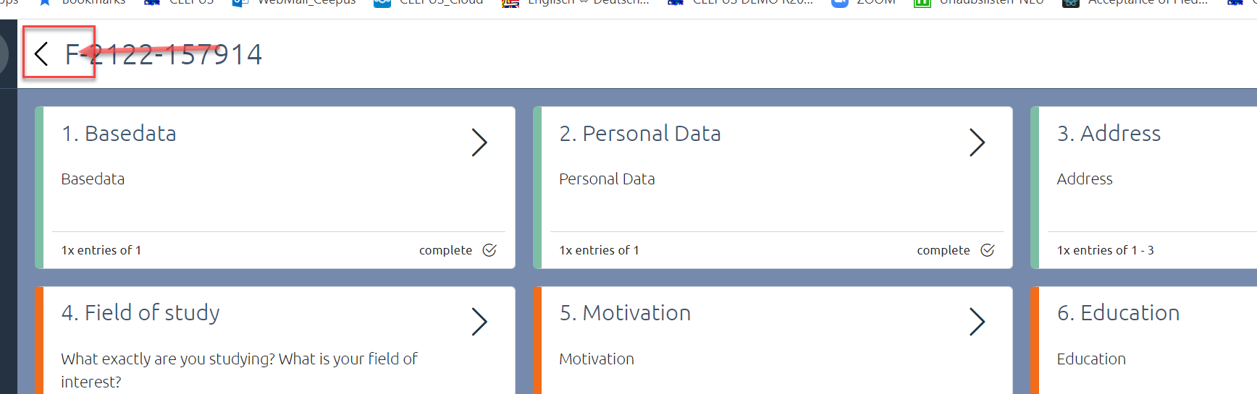

Press “submit” and confirm the workflow execution.
